GLEN-ED SPORTS ASSOCIATION MEETING DATE: January 22, 2018
ATTENDEE’S: Mark Rimkus, Chuck Hentz, Rob Landers, John Van Burskirk, Mike Walls, Lucas Weis, Kristy Fairburn, Ben Lankford, Matt Batchelor, Rachel Horsfall, Brian Basarich, Keith Schmidt, Jeremy Cecil, Randi Aldwardt, Clyde Berning, Jason Blaskie, Jon Reader, Matt Rakers, Clay Shaw, Mark Luer, Jacquie Berton, Chris Depping, Ron Smith Valenti, Jeff McMillian, Marty Chrenka, Connie Ruffini, Jeff Beck

ABSENT: Mike Beatty, Jason Porter, Samantha Sponeman, Karen Shoot, Chris Byron,

OBJECTIVES:
- Communicate Club Glen-Ed SIUE Turf Capital Projects
- Discuss Training Schedule and locations including important dates.
- Announce Skills, Summer Camps and Youth Academy Schedule

EXPECTATIONS: (of Meeting Participants)

PRESIDENT’S REPORT- Mark Rimkus
- Welcome
- Softball – Doing well and looking for gym space after giving it up.
- Lacrosse – 2 Team 24 players. Spring 2018. Offers to be made in 5-7 days.
- Basketball – 3 Teams doing well. Additional gym space is needed to increase participation.
- Sponsorships-Gatorade, Individuals – Gatorade has agreed to be Title Sponsor of the 2018 Glen-Ed Spring Kick-Off and the 3v3 Live. Sponsorship document will be available and communicated to the Glen-Ed community to reach out to local community business to support the club.
- Il Preservation Committee – approve to construct portable lights.
- Capital Project – Glen-Ed SIUE Turf – The Capital Project to build 2 turf fields with a maximum financing of $1,500,000. The Board approved it unanimously 27 Yes 0 No. 27 of a potential 28 teams approved. It.
- Team Snap Proposal-motion approved to increase fees up to $10 per player for team snap club wide.

REGISTRAR REPORT – Mae Hentz
- Guest Players – Mae indicated the guest player policy

COACHING & TRAINING REPOR-Chuck Hentz
- 2018 Spring & Age Group Training Schedule – Preliminary training schedule was presented.
- Goalie, Skills, and Summer Camp Schedule-Skills and Summer Camp Schedule was presented. Skills is every Saturday Feb 24, Mar 3,10,17, Apri 14,21,28 Rainout May 5th. Times are: birth year 2011-2007 from 9:00 AM-10:00 AM and 2006 -2003 10:00 AM – 11:00 AM. Summer Camp Schedule: Youth Day June 11-14 and Evening Camp July 16-20. College ID Camp is Aug 6-9
- Youth Academy (2012-2010) – Announced creation of Youth Academy for players ages 5,6,7
- Coach License Requirement and Update – Discussed the new USSF grassroots initiative and that the schedule for D licenses will be out in February.

MANAGING DIRECTOR OF PLAYER AND COACHES-John Van Buskirk
- Spring Training Topic groups revised: A: U8-U9 B U10- U11 C: U12+
- Player Recruitment

TREASURY REPORT-Chuck Hentz
- Tournament Fee Payments-Indicated to attendees that payment for MEL, Kixx, Gateway, SLSG, SASA will be made by the club.
- 2017-18 Player Payments-outstanding. Informed Manager, youth players with outstanding balances after Mar 1 will be suspeneded. HSB players with balances after Feb 15, will be suspeneded.
- 2018-19 Proposed Fees -Indicated fees are not expected to increase at this time except for capital projects to improve facilities.
- Monthly Operating Statements (Unaudited)
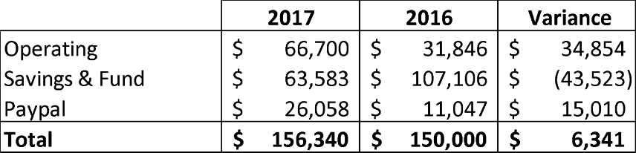
Financial Report Approval: Motion to Approve: Ben Lankfrord 2nd: Randi Aldwart

VICE PRESIDENT REPORT-Rob Landers
- GESKO Tournament – Discussed the significant increase in teams for the tournament. At this time in 2017, we are ahead of last year by 90 teams. We expect 220 teams.

Motion to Adjourn: Randi Aldwart 2nd: Jeremy Cecil Time: 8:33 PM

Next Meeting-February 26th, 2018 @ 7:00 PM - 8:30 PM

NEXT STEPS | WHO | WHEN
- Mark Rimkus research club wide use and cost of Team Snap for 2018-2019 | Mark | 2/22/18

